**DAILY ONLINE ACTIVITIES SUMMARY**

|  |  |  |  |  |  |  |  |
| --- | --- | --- | --- | --- | --- | --- | --- |
| **Date:** | **20-06-2020** | | | | **Name:** | **B.A.SOHANKUMAR** | |
| **Sem & Sec** | **4TH SEM A** | | | | **USN:** | **4AL18CS013** | |
| **Online Test Summary** | | | | | | | |
| **Subject** | | **DATA COMMUNICATION** | | | | | |
| **Max. Marks** | | **30** | | **Score** | | **25** | |
| **Certification Course Summary** | | | | | | | |
| **Course** | **FRONT END DEVELOPMENT-HTML** | | | | | | |
| **Certificate Provider** | | | **GLA** | **Duration** | | | **3.5 HOURS** |
| **Coding Challenges** | | | | | | | |
| **Problem Statement: Write a java program to count the number of bits to be flipped to convert A to B.** | | | | | | | |
| **Status:EXECUTED** | | | | | | | |
| **Uploaded the report in Github** | | | | **YES** | | | |
| **If yes Repository name** | | | | **LOCKDOWN CODING** | | | |
| **Uploaded the report in slack** | | | | **YES** | | | |

**ONLINE TEST DETAILS:**

Online test was 3rd and 4th module of DATA COMMUNICATION.The duration of the test was 30 minutes from 02.00pm to 02.30pm.Questions were of multiple choice.Score I received is 25/30.

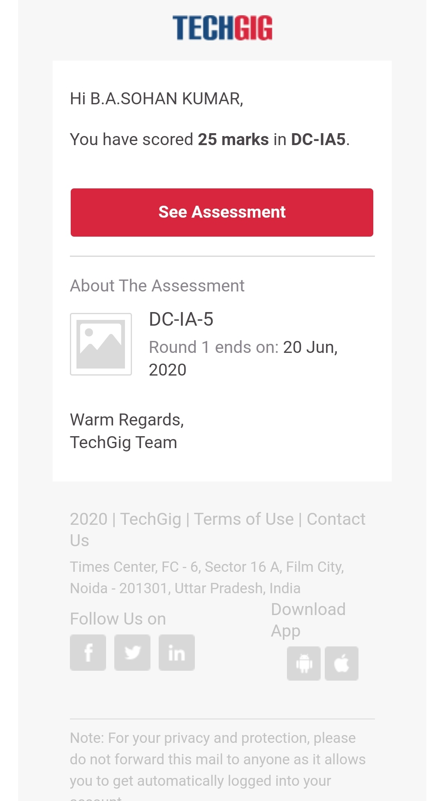

**CERTIFICATION COURSE DETAILS:**

Course:FRONT END DEVELOPMENT-HTML

Completed modules are Introduction to input elements,More on input elements,Lables,Forms,Method Attribute,HTML 5 Attributes,HTML 5 Input Elements,Text Area,Drop Down and Value Attribute,Radio button and checkboxes,Button Types,Div tag,Span tag,Block level elements,Inline Elements,Inline Vs Blocks,ID,Classes, Relationship between Elements and successfully completed the course.

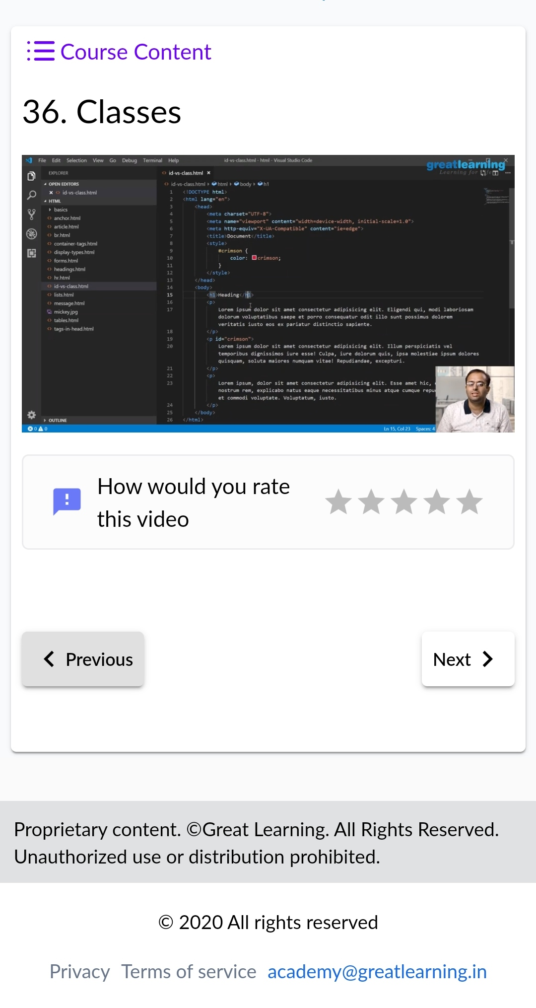 

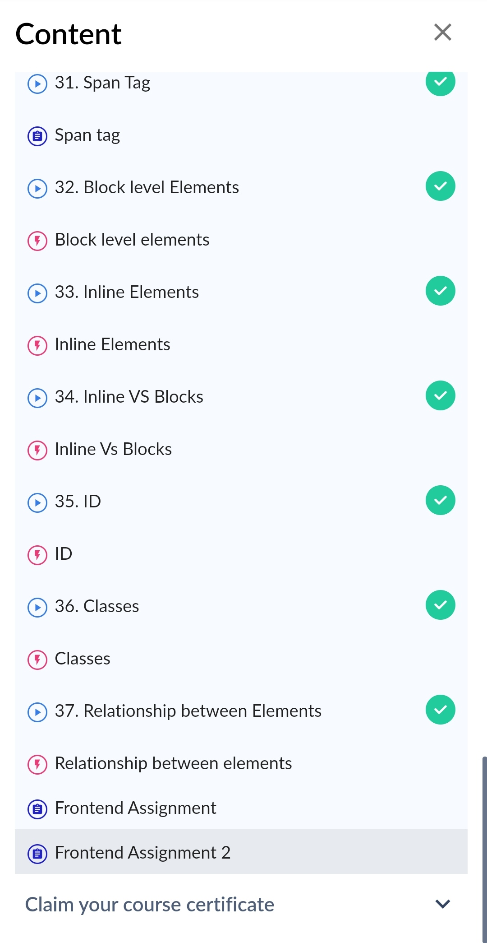COMPLETED MODULES

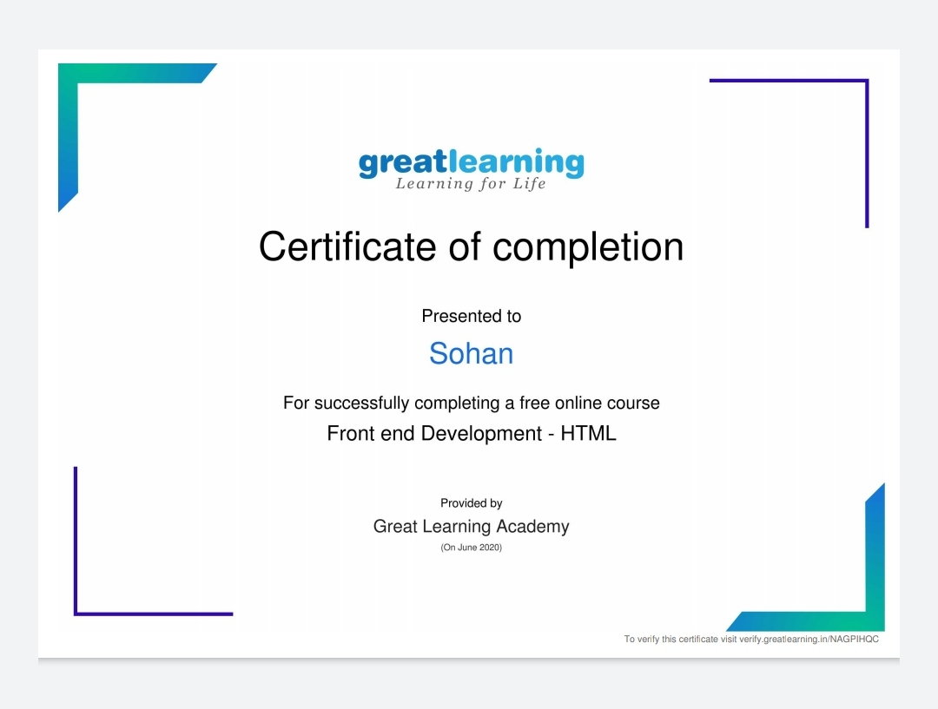

Above certificate is awarded for the completion of this course.

**CODING CHALLENGES DETAILS;**

1. Write a Java program to count number of bits to be flipped to convert A to B.Given two numbers ‘a’ and b’. Write a program to count number of bits needed to be flipped to convert ‘a’ to ‘b’.

Example :Input : a = 10, b = 20

Output : 4

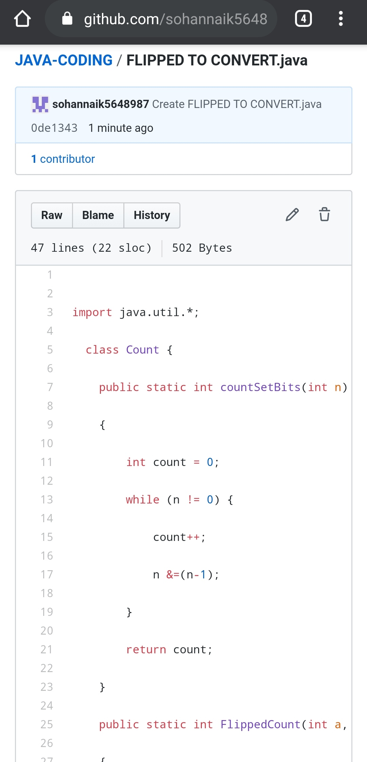

REPOSITORY LINK:https://github.com/sohannaik5648987/JAVA-CODING